JEETKUMAR KAMAN'
Computer Science Roll No. 64
Under supervision of

PROF. SHRUTI PANSURIYA
Shri PKM College OE B.Ed. — Junagadh
Affiliated to Bhakta Kavi Narsinh Mehta University

Under Internship mentor of
Sunny Gajera
Raj Multimedia Education
March 2026
Opp. Agriculture University Gate-

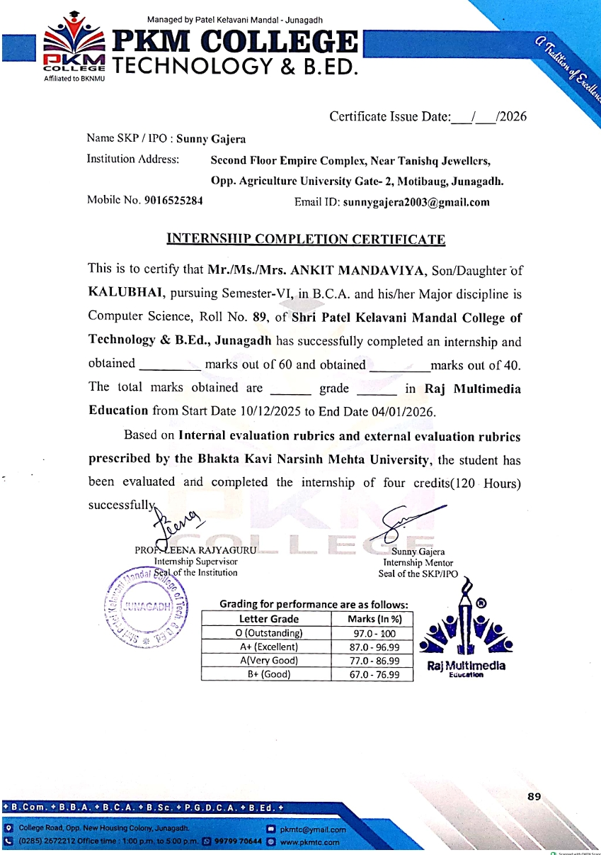
INTERNSIIIP COMPLETION

ACKNOWLEDGEMENTS:
- I would like to take this opportunity to express my sincere and heartfelt gratitude to Raj Multimedia Education, Junagadh, for providing me with the valuable opportunity to undergo internship training at their esteemed organization. This internship was a highly enriching and rewarding experience that allowed me to gain practical exposure in the fields of "Web Design, Graphic Design, and WordPress Development. The professional training environment, hands-on sessions, Structured assignments, and real-time project work helped me bridge the gap between theoretical knowledge and real-world industry requirements.
- I am deeply grateful to my Internship Mentor, Mr. Sunny Gajera, for his continuous guidance, encouragement, and professional support throughout the internship period. His practical teaching methods, clear explanations, and constructive feedback played a vital role in enhancing my technical knowledge and creative skills. Under his mentorship, I leamed the practical implementation of web and design technologies, improved my problem-solving abilities, and developed a professional approach toward project execution. His support significantly contributed to building my confidence and preparing me for industries challenges.
- I would also like to express my gratitude to my Internship Supervisor, Prof. Shruti Pansuriya, for her valuable guidance, academic support, and encou17gement. Her timely suggestions and supervision helped me stay focused, disciplined, and motivated, ensuing the successful completion of my internship training.
- I extend my sincere thanks to Dr. Jitendra Radadiya, Head of the Department, for his encumberment, leadership, and continuous academic support. His guidance motivated students to gain practical exposure and develop professional skills.
- I am also thankful to Shri Patel Kelvani Mandal College of Technology for its continuous support and encouragement. I express my gratitude to Bhakta Kavi Narsinh Mehta University, Junagadh, for making internship training a compulsory part of the BCA curriculum under NEP-2020, which has enhanced my skills, confidence, and career readiness.
- Finally, I would like to thank all the faculty members, staff, colleagues, and individuals who directly or indirectly supported me during the internship, their competition made this learning experience productive and memorable.

- INDEX: -
SR NO | TITLE | PAGE NO
 | ABOUT THE ORGANIZATION | 3
 | l. Brief History | 3
 | 2. Mission | 4
 | 3. Vision | 4
 | 4. Structure and Major Activities | 5
 | 5. Relevance to the Field of Computer Science | 6
(2) | OBJECTIVES OF TIIE INTERNSHIP | 7
 | l. Purpose of Choosing the Organization | 7
 | 2. Expected Leaming Outcomes and Employability Skills | 7
(3) | INTERNSHIP WORK | 8
 | l. Tasks Undertaken and Responsibilities Handled | 8
 | 2. Projects, Observations, and Practical Exposure | 8
 | -Canva Design Work | 8
 | -Photoshop Design Work | 14
 | -Figma Design Work | 16
 | -WordPress Website Development | 19
 | -Activities Performed: | 19
 | 3. Challenges Faced and Solutions Leamed | 19
(4) | LEARNING OUTCOMES | 25
 | l. Knowledge Gained | 25
 | 2. Skills Developed | 25
 | 3. Employability Enhancement | 25
(5) | CONCLUSION | 27
(6) | ATTACHMENTS | 28

+ ABOUT THE ORGANIZATION:


- Raj Multimedia Education (RME) is a well-known skill-based IT education institute that focuses on practical leaming and career development. The main goal of RME is to prepare students to become confident, skilled, and job-ready professionals.
- The The journey of Raj Multimedia Education staffed with a strong vision—to reduce the gap between traditional classroom education and real indust1Y needs. RME believes that practical skills are more important than degrees and that real learning happens by doing, not just by reading or listening to theow.
- The first branch of Raj Multimedia Education was established in Rajkot in the year 2016. This was the beginning of RME's educational mission with quality teaching and positive student results, the institute gained trust and recognition. Later, RME officially established its branch in Junagadh on 27th December 2022, which became an important milestone in its growth journey.
- Over the years, Raj Multimedia Education has grown steadily. Due to quality training, student trust, and successful results, the institute expanded to different locations. Today, RME operates 7 branches, serving students from venous regions and backgrounds. All branches follow the same teaching philosophy of practical learning, industry -relevant skills, and career-focused training.
- Raj Multimedia Education has trained and guided more than 5,000+ students in fields such as Graphic Design, UVUX Design, Web and App Development, Digital Marketing, and other IT-related areas. Many students are now working in reputed companies, doing freelancing, or running their own businesses in India and abroad.
- Raj Multimedia Education follows a 100⁰ 0 practical training model. Students learn through real-time projects, live practical assignments, modern software tools, and continuous guidance from experienced ment013. Along with technical skills, RME also focuses on developing confidence, creativity, discipline, and a professional attitude
- With a strong vision for the future, Raj Multimedia Education aims to expand further while maintaining high-quality education. RME continues to empower young students with the right skills and guidance to build successful careers,
- Raj Multimedia Education is not just an institute—it is a place where careers begin and futures are shaped

- To offer quality practical training that meets current indust1Y standards.
- To future creativity, technical competence, and professionalism among students.
- To provide hands-on training real projects and practical work.
- To help student’s gam confidence 111 using modern tools and technologies.
- To prepare students for jobs, internships, and freelancing opportunities. To bridge the gap between academic leaming and real-world indust1Y requirements. To encourage continuous learning and skill upgradation according to emerging technologies.
- To develop problem-solving, analytical thinking, and practical decision-making abilities in students.
- To promote ethical work practices, discipline, and responsibility in professional life.
- To support students in building strong portfolios and career-oriented projects.
Vision:
The vision of Raj Multimedia Education is to create a generation of highly skilled, confident, and job-ready professionals who can successfully build their careers in the fields of information technology, web development, graphic design, and multimedia. The Institute aim to empower students with strong technical knowledge, creative abilities, and professional values that enable them to meet the changing demands of the digital industry.
- The institute envisions providing a learning environment that encourages
Innovation, creativity, and continuous skill development. By focusing on practical training, real-time projects, and industry- oriented education, Raj Multimedia Education seeks to help students Transform their potential into professional excellence. The vision also includes preparing students not only for employment but also for entrepreneurship, freelancing, and lifelong leaming, enabling them to adapt to new technologies and global opportunities.
- Through quality education, experienced mentorship, and a student-centred approach, Raj Multimedia Education styles to contribute to the growth of the IT and digital sector by producing responsible, skilled, and future-ready professionals who can succeed in competitive professional environments.

- Structure And Major Activities
The institute conducts practical sessions, real-time projects, and guided fraining in:
- Graphic Designing
- Web Designing
- WordPress Website Development
- Digital Marketing
Through these activities, students are able to work on real projects, design digital content, and build functional websites, which prepares them for professional work environments.
- Relevance to the Field of Computer Science

- The activities and training provided by the organization are highly relevant to the Bachelor of Computer Applications (BCA) curriculum. The Internship offered valuable hands-on practical exposure that directly supports the subjects studied during the BCA course. By working on real projects, students are able to understand how theoretical concepts are applied m real-life IT and web development environments.

- Through this internship, I gained practical experience in website development, which helped me understand how websites are planned, designed, and implemented. This experience strengthened my knowledge of web technologies and improved my understanding of how different components of a website work together. It also helped me relate academic topics such as web programming and internet technologies to practical usage

- The training also focused on UI/UX design principles, which are important for creating user-friendly and visually attractive applications and websites. Leaming about layout design, colour usage, typography, and user interaction helped improve my design thinking and understanding of how users interact with digital products. These skills are vent useful for BCA students, as modem IT solutions require both technical and design knowledge.

- Another important area covered during the Internship was Content Management Systems (CMS), especially WordPress. This helped me learn how to create, manage, and update websites without complex coding. Understanding CMS platforms is very beneficial for BCA students because many real-world projects and organizations use CMS-based solutions for website management.
- In addition, I gained exposure to various design and multimedia tools, which enhanced my creativity and technical skills Using these tools helped me understand the importance of visual content m digital platforms and how multimedia elements improve user engagement

- Overall, these skills helped strengthen both my programming and design knowledge, improved my problem-solving and analytical abilities, and increased my confidence and employability in the IT and web development Industry. This internship experience perfectly complements the BCA curriculum and plays an Important role 111 preparing students for future
OBJECTIVES OF TIIE INTERNSHIP: -
- Purpose Of Choosing The Organization
- Raj Multimedia Education was chosen for the internship because of its strong emphasis on practical and skill-based training in the fields of web design and graphic design. The institute focuses not only on theoretical knowledge but also on hands-on leaming, which helps students clearly understand how concepts are applied i real working environments. This practical approach makes learning more effective and meaningful.
- One of the major reasons for selecting Raj Multimedia Education is its opportunity to work on real-time projects. These projects help students experience actual industry situations, such as Understanding client requirements, planning designs, and implementing creative and technical solutions. Working on live projects improves problem-solving skills and builds confidence to handle professional tasks independently.
- The institute follows a balanced teaching approach that combines creativity, technology, and practical leaming. Students are trained using modem tools, updated technologies, and industry-relevant practices, which helps in developing both technical knowledge and creative skills. The supportive learning environment, experienced trainers, and well-structured training modules further enhance the leaming experience.
- Overall, Raj Multimedia Education provided an ideal platform to gain industry-relevant experience, improve practical skills, and prepare for future career opportunities. The training helped me develop professional skills, enhance creativity, and increase confidence, making it a valuable choice for internship training and career growth.

- Expected Learning and Employability Skills
- Gaining hands-on experience with web and graphic design tools
- Understanding WordPress-based website development in real projects
- Leaming professional design standards and UUUX principles
- Enhancing creativity, problem-solving, and technical abilities
- Developing workplace readiness and professional confidence

INTERNSHIP WORK / LEARNING EXPERIENCES:
- Tasks Undertaken and Res onsibilities Handled
- Designmg posters, banners, and social media creatives for promotional use
- Editing and improvmg images using professional design tools
- Creating, updating, and managing WordPress website pages
Installing, configunng, and managmg WordPress plugins 10 enhance website functionality
- Projects, Obeservation And Practicle Exposure

- Canva Design Work
- As part of my design training, I completed five creative design projects using Canva- These projects Included the creation of posters, banners, branding materials, and social media posts.

- Tools Used: - Canva, templates, icons, fonts, shapes

- Learning Outcome: - I gained knowledge of layout design, effective colour combinations, and proper use of typography, which helped Improve the visual quality and appeal of digital designs.

 Brand Logo :


TELECOM

 Flayer:


 Business Card:

Jp
Telecom

JP TELECOM
INTERNSHIP REPORT BCA SEM-06
MOBILE SELL 'NG



BV:K.A ^{A} IA^{N}I JEETKUNLXR
: Photoshop Design Work :
INTERNSHIP REPORT BCA SEM-06
As part ofmy internship framing, I completed four design projects using Adobe Photoshop. These projects Included activities such as image editing, background removal, thumbnail designing, and image enhancement. Through these tasks, I leamed how to Improve the quality and visual appeal of digital images used for web and marketing pumoses.
Tools Used:- Adobe Photoshop, layers, crop tool, text tool, effects
Learning Outcome:- This work helped me develop skills in photo editing, visual composition, and professional image presentation, which are essential fov graphic and web design.
 YouTube Thumbnail:


 Website Slider 1:
APPLY
INTERNSHIP REPORT BCA SEM-06
 Website Slider 2:

 Website Slider 3:


SAMSUNG S25 ULTRA
Exchange Offer Available Capture Every Moment
IVEVV

BRAND
• Figma Design Work :-
As part of my intemship training, I completed one basic design projects usmg Figma. In these projects, I worked on image editing, background retnoval, thumbnail design, and Improvmg image quality These designs were mamly created for P01tfolio.
While working in Figma, I learned how to arrange elements properly, use frames and layers, apply text styles, and create clean and attractive designs. This helped me understand how modern UI and graphic designs are created.
Tools Used:- Adobe Photoshop, layers, crop tool, text tool, effects
Learning Outcome:- This work helped me develop skills 111 photo editing, visual composition, and professional image presentation, which are essential for graphic and web design
 Figma Portfolio:
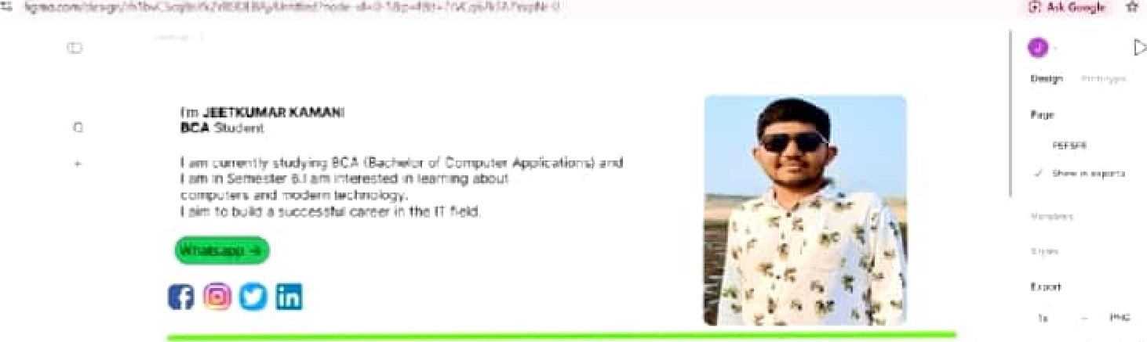
Personal Profile

Lar.guages Skill Extra Skill

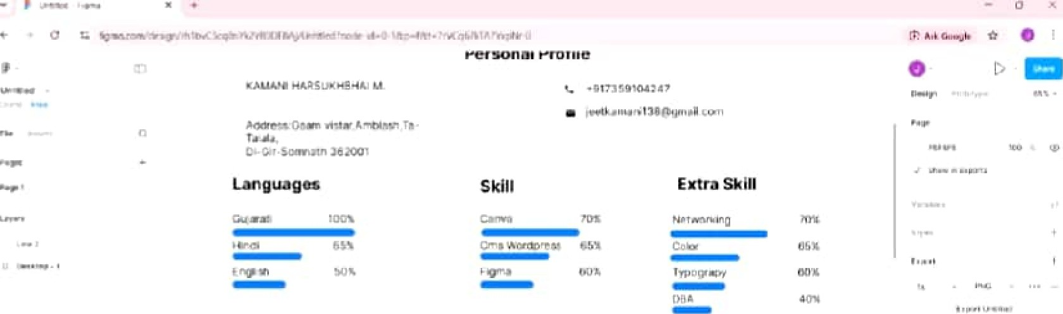

My Wort
Canva Cms Witr
Wordpress
My
Work
 Exm•t
Conva
Crns
With
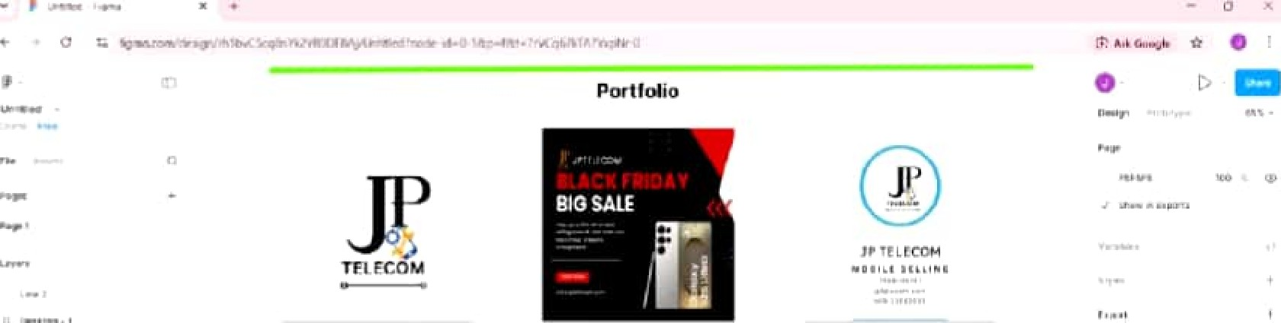
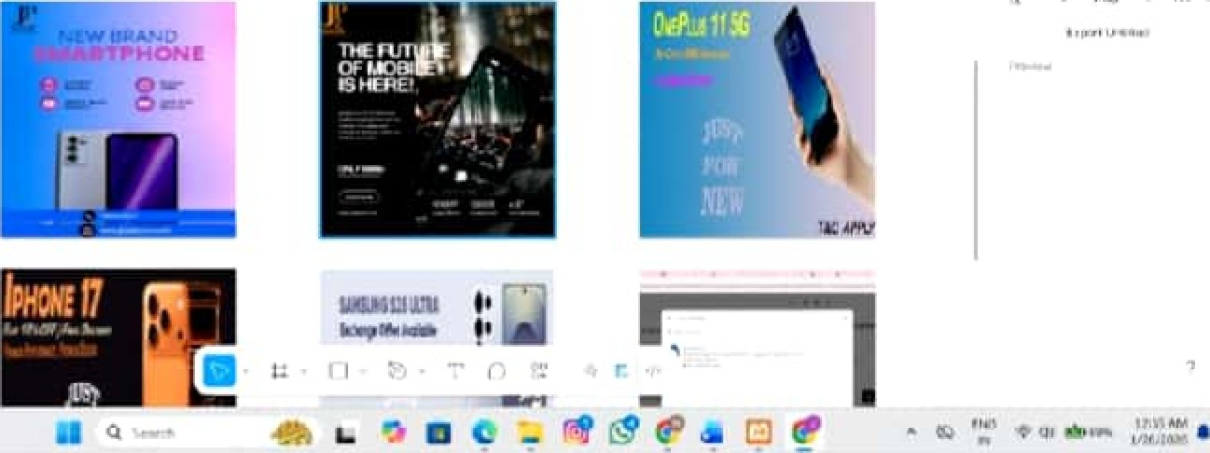


Declaration


: WordPress Website Development :-
Dilling the internship, I developed a complete WordPress website using Content Management System (CMS) tools. This project allowed me to understand how modem websites are created, customized, and managed without extensive code.
I was involved in the followin º activities:
- Installing and customizing themes
Creating Important website pages such as Home, About, Services, and Contact Installing, configuring, and managing plugins to Improve website mctionality
Plugins Used:
Elementor for page building
- WooCommerce for e-commerce features
- SEO Plugin for search engine optimization
Challen es Faced and Solutions Learned:
Challenge | Solution
Design alignment issues | Practiced and applied grid-based layouts for better visual snucture
Plugin conflicts | Updated and reconfigured plugins to ensure smooth fimctionality
Color mismatch | Applied color theolY principles to achieve consistent and appealing designs
JEETKIUM.XR
Home Page:
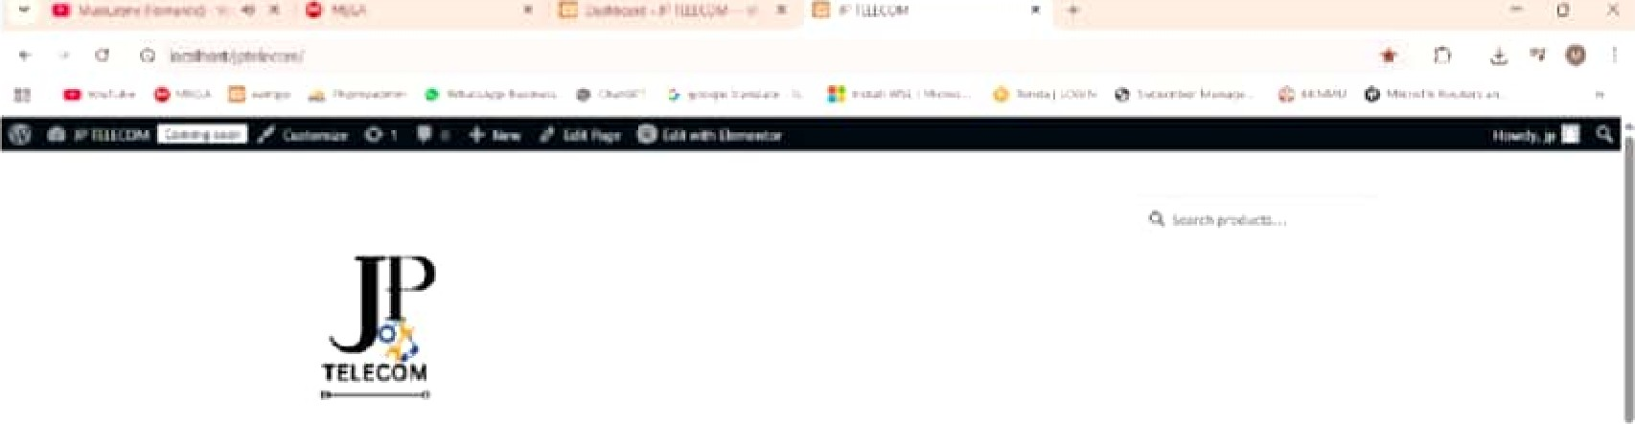

Home

 APPLY


we Are Hiring Since 1998

Policies Contact Us

 About Us:

About Us

About CJs

MR JEETFAMANI
FOUNDER & CHAIRMAJN JP TELECOM




 Contact Us:

Contact IJs

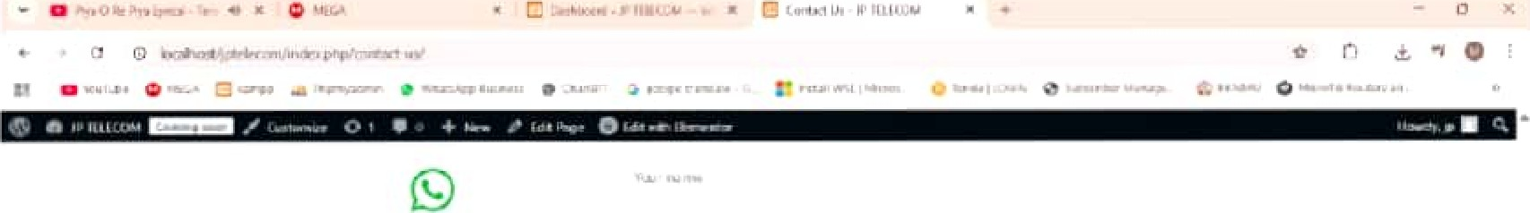
Whatsapp
Instagtam
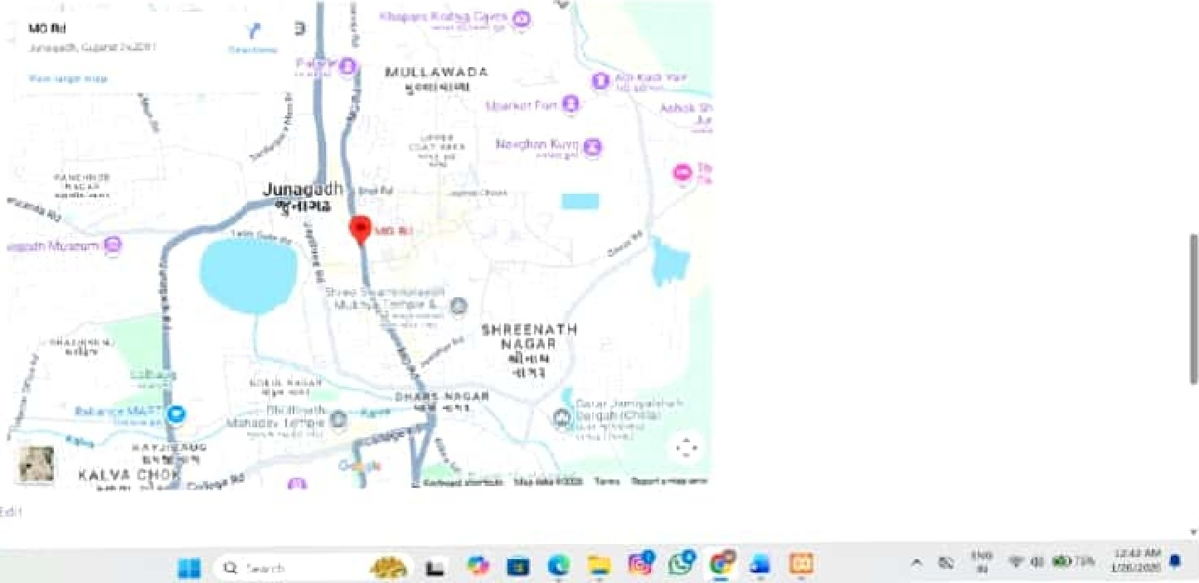

JEEU<U-ALXR
+ LEARNING OUTCOMES: -
Computer & IT Fundamentals:
- Through this intemship, I developed a strong understanding about today's trend in IT Indusåy. My digital literacy improved significantly, along with the ability to use IT tools in a professional environment. I also gained basic knowledge of intemet working and cyber safety practices.
Web Development Knowledge:
- The intemship helped me understand how websites are designed and function in real life. I leamed the basic structure of HTML and CSS, pnnciples of responsive web design, and the fundamentals of client—server architecture. I also gained practical knowledge of domain, hosting, and website deployment.
CMS & WordPress Skills:
- I gamed hands-on expefience m working with WordPress CMS. I learned how to create websites, customize themes, install and manage plugins, and organize website content and pages. These skills enabled me to manage and maintain a fully functional website independently.
UI/UX & Design Skills:
- The intemship strengthened my understanding of design fundamentals, including color theory, Wpography, layout, and visual hierarchy. I leamed how to design user-fiiendly interfaces and create visually attractive social media and branding creatives that enhance user engagement.
Graphic Design & Tools:
- Ileamed to use Canva professionally for creating digital designs and Photoshop for basic mage editing. This improved my creativity, visual thinking, and understanding of design consistency and branding concepts.
Analytical & Problem-Solving Skills:
- The intemsllip enhanced my ability to identify design and technical issues and apply logical solutions. I leamed how to correct enors, improve design accuracy, and maintain website functionality through careful analysis and troubleshooting.
Professional & Soft Skills:
- I developed impoltant workplace skills such as communication, teamwork, time management, and discipline. I also learned how to document projects and present work in a professional manner.
Employability & Career Readiness:
- This intemsllip helped me becmne Indust1Y-ready by building confidence in handling real-world projects. I gained awareness of IT career opportunities and unproved my professional attitude, making me prepared for future intemships, jobs, and freelancing work.
Documentation & Reporting Skills:
- Through this intemship, I leamed how to prepare proper documentation for projects, including requirement analysis, task descfiptions, progress Ireports, and final submissions. This helped me understand the importance of clear documentation for future reference and professional communication.
Understanding of Industry Workflow:

- I gained knowledge about how IT and design projects are planned, executed, reviewed, and delivered in an organization. This helped me understand professional workflows, client requirements, revisions, and quality standards followed in the industry.
Team Collaboration & Coordination:
- The intemship taught me how to work effectively as palt of a team. I learned how to coordinate with trainers and peers, share ideas, accept feedback positively, and contribute responsibly to group tasks and projects.
Adaptability & Continuous Learning:
- I developed the ability to quickly adapt to new tools, technologies, and project requirements. The intemship encoumged me to learn continuously, explore new design trends, and update my technical knowledge according to industry needs.
Ethics & Professional Responsibility:
- I leamed the impoltance of professional ethics, punctuality, accountability, and dedication m the workplace. This expelåence helped me develop a responsible attitude toward assigned tasks and improved my commitment to delivering quality work on time.
+ CONCLUSION:
Tlle intemship at Raj Multimedia Education, Junagadh proved to be a highly meaningful, enriching, and productive leanling expelience. This training program provided me with an excellent opportumty to bridge the gap between the theoretical concepts leamed during my BCA academic studies and their practical implementation in a real professional environment. Througll this internship, I was able to understand how classroom knowledge is applied in real-world IT and design projects.
Dilling the mtemship period, I actively worked on various projects related to web design, graphic design, and WordPress development. These tasks helped me gain hands-on experience in designing user-mendly websites, creating visually appealing graphics, and managing dynamic content usmg WordPress. I leamed the importance of layout design, color combinations, tnography, responsiveness, and usability while developmg web pages and digital content. Working on these projects gave me a clear understanding of how digital solutions are planned, developed, tested, and delivered to meet client requirements.
This Internship significantly helped me strengthen my technical skills, Including the use of web technologies, design tools, and content management systems. Along with technical knowledge, I was able to improve my creativity and problem-somng abilities by working on real-time challenges and finding practical solutions. Each task encouraged me to think logically, creatively, and professionally, which enhanced my overall confidence.
In addition to technical leaming, the intemship also contributed to my personal and professional development. I leamed the importance of discipline, time management, teamwork, and effective communication 111 a professional workspace. Interacting with trainers and team members improved my communication skills and helped me understand workplace ethics, responsibilities, and professional behavior. I also gained expefience in handling tasks independently while meeting deadlines and maintaining quality standards.
Overall, the internship experience at Raj Multimedia Education has played a vital role in shaping my career outlook It has provided me with greater clality and confidence regarding my future career path in the IT, web development, and digital design field. This intemship has not only enhanced my techmcal expertise but also prepared me to face real-world professional challenges. I consider this training program an important milestone in my academic journey and a strong foundation for my future professional groM11.
ATTACHMENTS:
Weekly Log Book
Internship Completion Certificate

